Virtuo Premium planks are suitable for indoor residential use and light commercial installations.

|  |
| --- |
| **IMPORTANT:**   * Read all instructions before proceeding. * Virtuo Premium is only suitable for indoor use. * Check for any visual defects or damage before and during installation, and return any damaged product to place of purchase.  *Gerflor will not be responsible for installation cost claims where flooring was installed with obvious defects.* * Subfloors must be clean, smooth, flat and dry. * Installation temperature should be between 15 to 28⁰C, ideally at a room temperature of 22⁰C. * The flooring should be maintained in this temperature range thereafter. Protect your floor from excessive direct heat, temperature variation or direct sunlight using curtains, blinds and temperature controls.   **For best results assess the site and building conditions carefully. Installation should comply with Australian Standard AS1884-2012 for Floor coverings – Resilient sheet and tiles – Installation Practices. If you are unsure about any aspect of the installation, contact Gerflor customer service.** |

**Material inspection** Check each pack to ensure that batch numbers are the same. Inspect the product and do not cut, fit or install any material that has visible defects. Gerflor will not be responsible for material installed with obvious defects.

**Site conditions** The ambient temperature must be between 15 and 28⁰C. These temperatures must be maintained 24 hours before, during and at least 24 hours after the installation is complete. The boxes of planks must be stored flat in these conditions for at least 24 hours prior to installation. The planks must not be bonded if the temperature of the subfloor is less than 10°C.

**Installation in areas of high heat or direct sunlight** Gerflor strongly recommend that all precautions are taken to avoid the flooring being exposed to prolonged periods of direct sunlight. As required under Australian Standards the flooring should be protected with the use of blinds or curtains. In areas that may be exposed to direct sunlight or high heat from time to time Gerflor recommend that section is installed using a two part heat and moisture resistant adhesive.

**Installation on heated slabs** Virtuo Premium can be installed on heated slabs provided the following precautions are taken:

* The heating must be switched on for at least 48 hours and then turned off again for at least 48 hours prior to installation. This is to remove any residual moisture created when the heating system was installed.
* The heating should remain off during installation and for at least 72 hours after completion.
* The heating should be turned on again and increased at a maximum of 2 degrees per day from ambient temperature to a maximum of 28⁰C.
* At no time should the maximum of 28⁰C be exceeded.

Virtuo Premium can be installed on almost any correctly prepared solid surface. Subfloors must be clean, smooth, flat and dry. Please ensure you sweep and/or vacuum all subfloors to remove dust and debris before starting your installation

­­­­­­

**Concrete subfloors**

Concrete should be constructed using good building practices and have an intact vapour barrier installed. Concrete should be flat and level to a minimum deviation of 4 mm over a 2 m length at any point. If repair is required use a suitable levelling compound. Any holes or deviations should be filled with a suitable patching compound. Any lumps or old adhesives should be removed. Concrete should be dry to a minimum of 75% using an in-situ moisture test ASTM F2170, as specified in Australian Standard 1884-2012. If the dampness exceeds 75%, a waterproof system is suggested before installation begins.

**Timber subfloors**

Timber subfloors should be overlaid with a purpose made wood flooring underlay. Prior to this the wood subfloor should be solid and flat with no nails protruding. Cupped or warped boards should be sanded flat. Wood floors should be flat and level to a deviation of no greater than 4 mm in a length of 2 m at any point. Wood floors should be sanded clean and any excessive deviations repaired with a suitable patching compound.

**Existing floor coverings**

Virtuo Premium should not be installed over existing vinyl, rubber or linoleum, textile flooring, including carpet, and any type of underlay must be removed. Existing solid floors including ceramic tiles and terrazzo can be installed over using an appropriate levelling compound.

**Adhesive**

Adhesive for wood or concrete should be a hard set acrylic type. Spray adhesives, contact adhesives or pressure sensitive adhesives are not suitable for Virtuo Premium installation. Adhesive should be applied with a trowel (as shown) and allowed to set up prior to the plank placement. Adhesive manufacturer’s recommendations should be followed with regards to coverage, set up and working time.

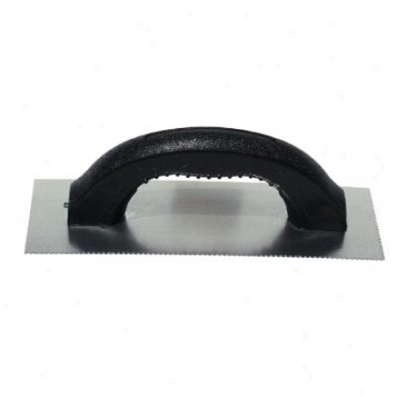

**Tools & Products**

* Tape measure
* Pencil
* Sharp utility knife
* Broom
* Acrylic flooring adhesive
* Adhesive trowel
* Heavy roller or hand roller

**GETTING STARTED:**

Ensure room temperature is maintained between 15 and 28⁰C before during and after installation.

The planks should be installed in the direction of the traffic flow in your room. It is recommended to lay the planks parallel to the longest room dimension.

Carefully measure the width of the room and mark the centre line, determine the width of the last row of planks. If the width of the last row is less than 50 mm the width of the first row should be adjusted to allow a larger cut.

**INSTALLATION:**

Planks should be drawn from three boxes to avoid shade variation. Position the first row of planks along the centre line. Once you reach the end ensure the cut piece will be longer than 150mm, if not adjust your starting position. To find the exact size of the final plank in the row position a full plank (plank 2) against the skirting board and over the last plank (plank 1).

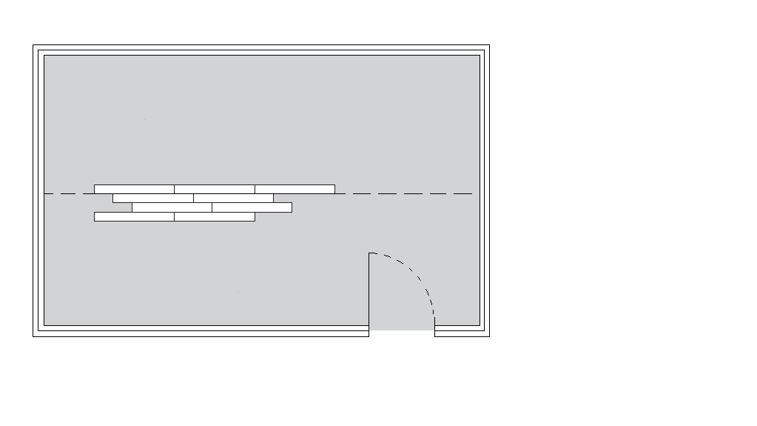

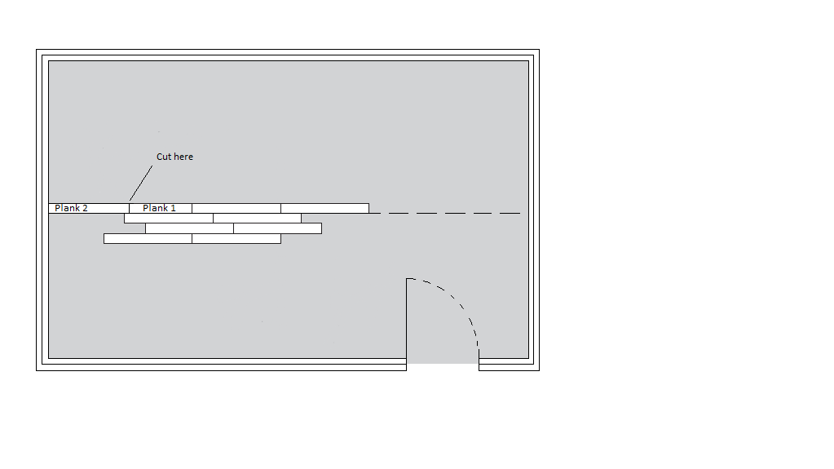

Score a line on the last plank then deep cut along the line. Continue this way until you have at least three rows complete. Mark pencil line along the last row and remove the planks keeping in the correct order for replacement.

Ensure the area is clean and dust free then trowel the adhesive between the lines. Allow adequate time for the adhesive to set up and replace the planks in the order they were removed. Once the planks are in place roll with a heavy roller or hand roller.

**COMPLETION:**

Do not place heavy furniture on the planks for at least 72 hours. After 48 hours the floor can be washed using a neutral detergent ensuring the water is not allowed to pool for an extended period of time.

**MAINTENANCE:**

For best results apply Gemini vinyl floor polish or similar, this will protect your vinyl flooring and help maintain an ‘as new’ appearance. For general cleaning we recommend a damp mop using a mild neutral detergent such as Versadet vinyl floor cleaner or similar.

Never use abrasive pads or cleaners, strong alkaline detergents, ammonia, chlorine detergents or undiluted bleaches.

Always wipe spills away immediately with a damp cloth or sponge.

Use a non-rubber backed mat in doorways and entrances to inhibit any excess dirt, grit etc.

Protect the flooring with MDF or Masonite boards when moving furniture or heavy objects.

Ensure the proper use of floor protector pads under the legs of furniture etc. to limit any scratching.

Be aware that bitumen, and rubber can permanently mark your floor, leaving a yellowish stain. This includes rubber used in rubber-backed mats, rubber wheels on trolleys, rubber feet on stools and other furniture, rubber soles on low cost shoes or slippers.

**REPAIR:**

Planks damaged accidently can be gently warmed with a hair dryer and removed with a small scraper. Scrape the subfloor clean, spread adhesive and re-install a new plank.

Produced by Gerflor Australia Sept 2016