Specification

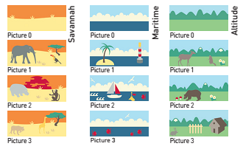

Decofresc –Early childhood-
decorative protection fresco

- Description: decorative protection fresco (Savannah, Maritime or Altitude Decofresc as manufactured by SPM) from rigid and antibacterial PVC achieving Bs2d0 fire rating with solid colour and slightly textured surface (Optimixt grain as manufactured by SPM). 3 m long, 1.30 m high (indivisible), 2 mm thick.
- Environment: no heavy metals and no substance potentially subjected to any REACH restriction are used in its manufacture, nor PBT/BPA. The calcium-zinc thermal stabilisation process is used. The emission level of volatile substance in inside air has been tested according to ISO 16000-6 and is very low (A+) according to the French regulation (23 March 2011 nr 2011-321 Decree and 19 April 2011 Order). 100% of the product are recyclable.
- Colour: selected by architects from manufacturer’s standard range
- Installation method: glue as per manufacturer’s instructions.

Frescoes made from cut-to-size Decochoc panels.
Delivered flt and pre-assembled, they are to bring together when installing and not fi on curved walls.

